AIMS Mathematics, Volume (Issue): Page

DOI:   
Received:  
Revised:  
Accepted:  
Published:

https://www.aimspress.com/journal/Math

***Type of article***

**Evaluation of Pixhawk-Based Quadcopter Flight Performance: “A Comprehensive Testing Approach”**

**Sai Rohan P.1, Dileep Kumar S. 1, Khwaja Moinuddin S. 1, Pavani N. 1**

**Dr. K. K. Deepika2**

1B. Tech, Dept of EEE, Vignan’s Institute of Information Technology (A), Visakhapatnam, India.

2Assistant Professor, Dept of EEE, Vignan’s Institute of Information Technology (A), Visakhapatnam, India.

**Correspondence:** [20l31a02e1@vignaniit.edu.in](mailto:20l31a02e1@vignaniit.edu.in) ; [20l31a02f2@vignaniit.edu.in](mailto:20l31a02f2@vignaniit.edu.in) ; [21l35a0223@vignaniit.edu.in](mailto:21l35a0223@vignaniit.edu.in) ; [20l31a02d1@vignaniit.edu.in](mailto:20l31a02d1@vignaniit.edu.in) ; [kkdeepika@vignaniit.edu.in](mailto:kkdeepika@vignaniit.edu.in)

**Abstract:** This paper provides a thorough testing review of the flight performance of quad- copters based on the Pixhawk. The purpose of the study is to evaluate the quad- copter’s performance in a range of operating scenarios, including conventional flight circumstances and its reaction to outside variables like wind direction and speed. To comprehend the quadcopter’s performance characteristics, data gathered during testing, such as acceleration graphs showing flight length, altitude stability, position stability were examined. The outcomes show that the quadcopter has good flying characteristics, as seen by its ability to hover steadily and react to directions from ground control. Additional analysis indicates that with payload weights under 250g, obtaining altitude and stability with less variance is more feasible.

**Keywords:** UAV; Pixhawk; GPS; Wind speed; Stability.

**Mathematics Subject Classification:** xx, xx

1. **Introduction to Pixhawk-based quadcopters**

Extensive testing is necessary to guarantee Pixhawk-based quadcopter’s operational reliability, safety, and performance in a variety of real-world circumstances. Analyzing and validating the quadcopter’s flight performance, stability, accuracy of navigation, and reaction to external stimuli are all part of this assessment. Testing techniques improve the quadcopter’s operational procedures, control algorithms, and design by learning from its behavior in various flying environments [1].

* 1. *Overview of Pixhawk Flight Controller*

This section offers an overview of Pixhawk flight controller, including their architecture, features, and capabilities, based on previously published works and technical documents [1]. Regarding unmanned aerial vehicles (UAVs), the flight controller is a vital piece of equipment that is renowned for its dependability, adaptability, and rich feature set.

The core of the Pixhawk ecosystem is the STM32F427, which acts as the primary processor for communication, navigation, and flight control. One of the most recent Pixhawk models, Pixhawk 4.2.8, combines a robust architecture that integrates several sensors, interfaces, and communication protocols with a small form factor to enable accurate and autonomous flying operations.

* 1. *Interfaces*

The Pixhawk 4.2.8 has interfaces for both Serial Peripheral Interface (SPI) and Inter-Integrated Circuit (I2C), which allow for easy integration with a wide range of external sensors and peripheral devices. These interfaces provide accurate data collecting that is necessary for flight control and navigation by permitting communication with a variety of sensors, including magnetometers, gyroscopes, accelerometers, and barometers.

**Pulse width modulation (PWM) outputs**: These PWM outputs enable the Pixhawk to control its motor direction and speed, which promotes maneuverability and steady flying.

**Universal Asynchronous Receiver-Transmitter (UART) ports**, which function as interfaces for various communication devices, like GPS modules and telemetry modules. A bidirectional serial connection is made possible via these ports, which makes it easier to send and receive orders from external devices and send telemetry data to ground control stations.

**Accurate Positioning and Navigation Data:** Coordinates provided by the Pixhawk high-precision GPS module; this data is crucial for autonomous flight operations. With the help of this module, the Pixhawk can determine its location, velocity, and altitude with an impressive degree of precision, which makes waypoint navigation and mission planning much easier.

**Inbuilt Sensors:** The Pixhawk is outfitted with a comprehensive array of inbuilt sensors, including magnetometers, barometers, accelerometers, and gyroscopes, which enable the acquisition of crucial information for the purposes of attitude estimation, stabilization, and altitude control. These sensors provide steady and flexible flying performance in spite of difficult external circumstances.

**Telemetry Options:** The telemetry enables wireless communication between itself and ground control stations by supporting a wide array of telemetry options, including Wi-Fi, Bluetooth, and long-range radio systems. These telemetry settings enable command and control and real-time telemetry transfer.

1. **Flight Testing Procedures**

In the following paragraph section describes pre-flight checklists and safety procedures, including equipment checks, battery inspections, and communication tests, to verify the quadcopter's safety before each flight test. The quadcopter's ability to maintain a stable hover position without drifting or oscillating is tested, as its stability in varied flying regimes, such as changing altitudes and orientations relative to wind velocity.

* 1. *Types of Tests*
* Altitude hold test
* Stability test
* Speed test
* Payload test
  1. *Altitude hold test*

The altitude hold test evaluates the drone’s stability during a sustained altitude hover, MS5611 barometer sensor is used by the UAV’s flight controller to monitor ambient pressure and calculate it into altitude. The original height and measured altitude parameters are Pos.Alt and Gps.Alt [2]. After altitude locking, the quadcopter is allowed to hover at a specified height for a period of time; for extracting the logs, flight controller is connected to the Mission Planner software [3] using a USB connection or telemetry module [4]. The altitude test was performed at two altitudes: 10 and 20 meters, Graphs were plotted only when the data logs are transformed into csv files using UAV log viewer application.

The altitude test was performed at two altitudes: 10 and 20 meters, Graphs were plotted only when the data logs are transformed into csv files using UAV log viewer application.

Case 1: Altitude test at 10m

Figure 1 depicts the graph for Case 1, which was done at a moderate wind speed of 13 kmph at an altitude of 10m. The observed altitude variance between the original and true altitudes was 4.94m, and the error percentage deviation was 25.84.

Case 2: Altitude test at 20m

Figure 2 provides the observed graph from the test, which shows that at 13Kmph wind velocity, the observed altitude discrepancy between original and true altitude is 9.5m at an altitude of 20m, with an error percentage deviation of 41.41.

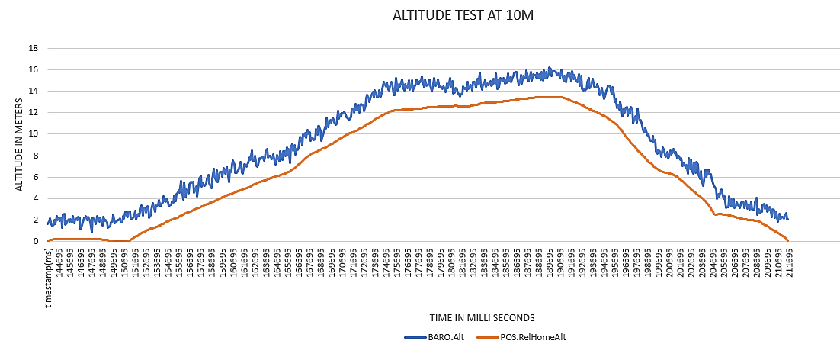

**Figure 1.** Altitude test at 10m

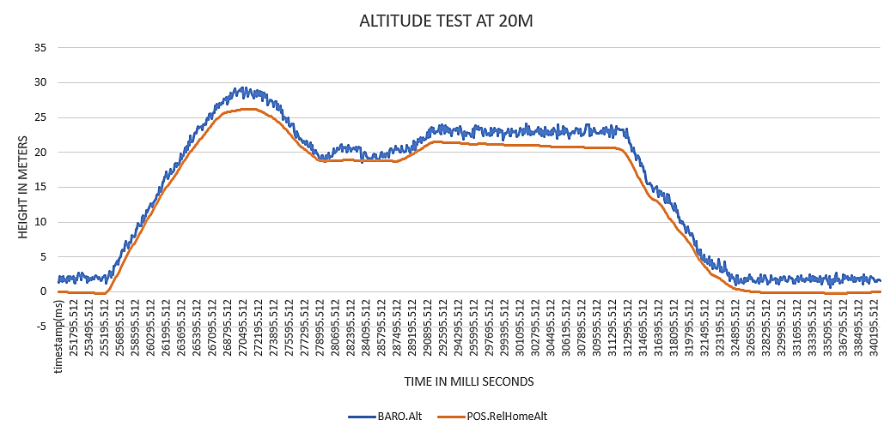

**Figure 2.** Altitude test at 20m

From the above test results, it was concluded that as the altitude increases, the standard deviation also increases because of air turbulence and wind gusts, resulting in a resulting in a decrease in air pressure, which decreases sensor accuracy.

* 1. *Stability Test*

During the stability test, it is critical to determine the gyroscope's stability to verify the quadcopter's ability to retain balance and alter speed in response to gyroscopic errors [2]. This test comprises graphing the acceleration graph along the X, Y, and Z axes to determine the stability of the MPU6000 gyroscope at elevations of 10 and 20 meters above ground. The allowable ranges for acceleration along the X, Y, and Z axes are 0–3 m/s2, 0-3.3 m/s2, and 5–15 m/s2, respectively. The standard deviation is then calculated for each axis to determine the consistency and dependability of the gyroscope readings, Notably, this test is done in controlled settings with wind speeds of 13 kmph at both elevations, confirming its validity and precision [5].

Case 1: Stability test 10m Altitude

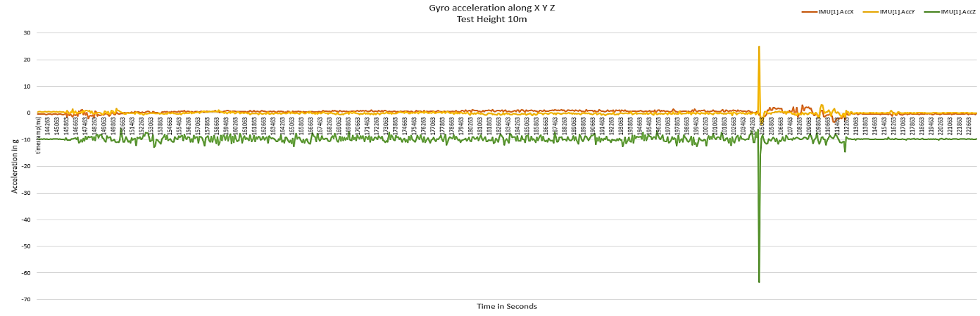

**Figure 3.** Stability test at 10m

From the above graph, it is observed that the average X-axis acceleration is 0.323 m/s2, the Y-axis acceleration is -0.0173 m/s2, and the and the Z-axis acceleration is -9.8 m/s2. The standard deviations across the X axis, Y axis, and Z axis are 0.71, 0.98, and 2.12.

Case 2: Stability test 20m Altitude

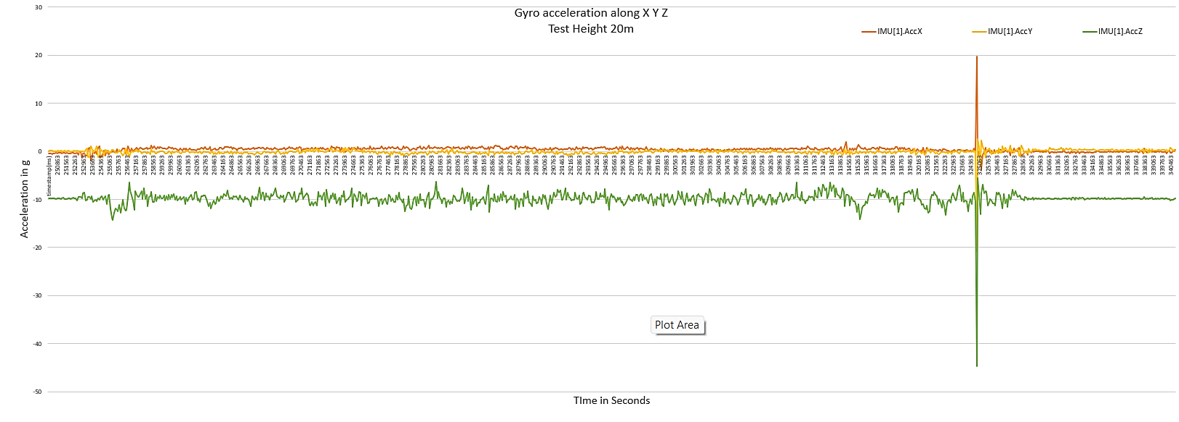

**Figure 4.** Stability test at 20m

From the above graph 2, it can be seen that the average X-axis acceleration is 0.373 m/s2, the Y-axis acceleration is -0.1063 m/s2, and the and the Z-axis acceleration is -9.84 m/s2. The standard deviations across the X axis, Y axis, and Z axis are 0.78, 0.77, and 1.53.

From the above observations, it is concluded that the GPS position or the stability does hold at any point of altitude within the range.

* 1. *Speed test*

A UAV speed test is performed in stabilize mode, when it is driven to maximum velocity. For testing purposes, the quadcopter is initially set to loiter mode before being switched to SwB2- SwC3 stabilize mode. [6] The quadcopter's maximum fixed ground speed is 10m/s, which may be adjusted using the mission planning program. The UAV's velocity is determined by the environment's wind velocity; if the external wind velocity (air gusts) is high, the flight controller takes longer to settle the oscillations and steady the drone [7]. When the UAV stabilizes, its velocity drops to minimize propeller damage. At greater altitudes, the drone's speed stays constant, but its stability is compromised. This test is done at 75 percent throttle.

Case 1: Speed Test At 10m Altitude

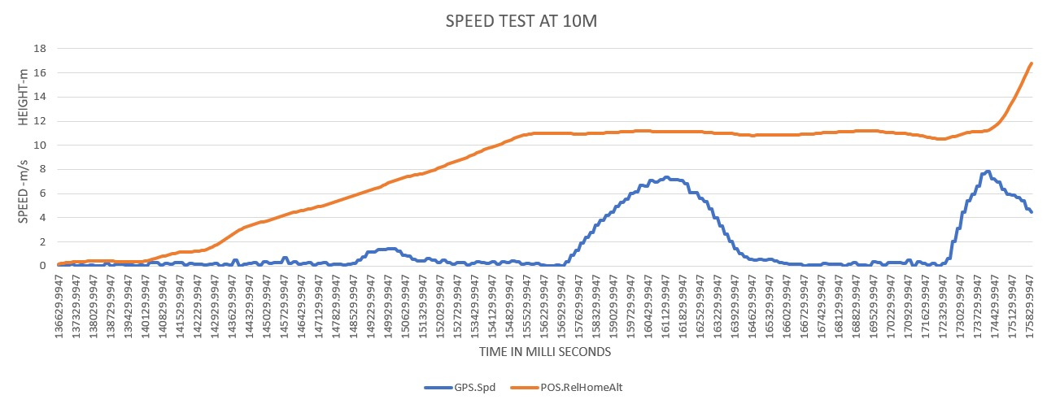

**Figure 5.** Speed test at 10m

In the first test instance, the quadcopter's highest velocity is 7.80 m/s, with an average velocity of 2.82 m/s during the test.

Case 2: Speed Test At 20m Altitude

In the 20-meter test, the maximum velocity reached by the quadcopter is 7.60 m/s. The average velocity throughout this test is 2.17 m/s.

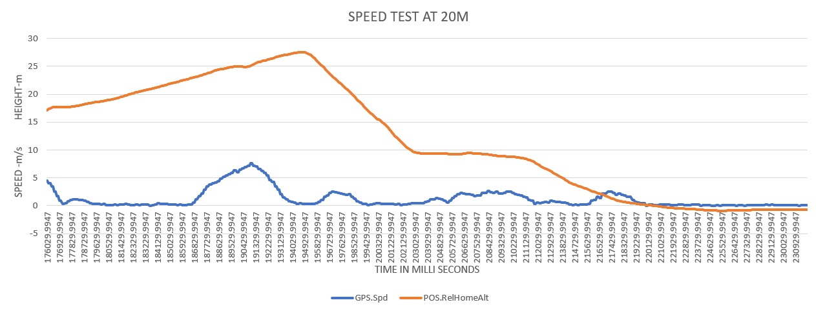

**Figure 6.** Speed test at 20m

The data analysis led to the conclusion that the drone's speed is determined by its height as well as its stability. Because the air density decreases as altitude increases, the propellers must spin faster to create the needed amount of power downward to hover; owing to the greater RPM of the motors, the flight controller will have problems finding a stable position.

* 1. *Payload Test*

The payload test of the UAV determines the maximum weight it can carry [8]. To conduct the test, the payloads are mounted to the bottom of the UAV. The payload weights for the set of tests are 250g, 300g, and 500g. Generalized payload calculations are done and a detailed discussion of the payload test is presented in this section.

**Max payload Calculations**

When the push equals the drone's precise weight, the drone achieves balance and hovers. To achieve flight, a traditional drone's propulsion needs be twice its weight, or a 2:1 thrust-to-weight ratio. A drone with a total weight of 1500 g, including the batteries, requires a minimum thrust of 3000 g to fly. However, the overall drone thrust is 3200g.

**Case 1: Payload weight - 500g**

If we add 500g to the drone, the overall weight should be 2000g, but the thrust generated is 3200g, requiring an extra 800g. As a result, the thrust-to-weight ratio will drop below 1.6:1, and the drone will be unable to fly.

**Case 2: Payload weight - 300g**

When 300 g are added to the drone, the total weight should be 1800g, but since the thrust produced is 3200g, the additional thrust required is 400g. So if the thrust-to-weight ratio is decreased to 1.77:1, the drone will achieve partial flight.

**Case 3: Payload weight - 250g**

When 250 g added to the drone, the total weight should be 1750g, but since the thrust produced is 3200g, the additional thrust required is 300g. So, if the thrust-to-weight ratio is 1.82:1, the drone will achieve flight but will not be able to fly at full thrust.

**Test observation**

The payload test of the UAV determines the maximum weight it can carry. (Estevez, Garate, Lopez-Guede, & Larrea, 2024) To conduct the test, the payloads are mounted to the bottom of the UAV. The payload weights for the set of tests are 250g, 300g, and 500g. Generalized payload calculations are done and a detailed discussion of the payload test is presented in this section.

**Max payload Calculations**

When the push equals the drone's precise weight, the drone achieves balance and hovers. To achieve flight, a traditional drone's propulsion needs be twice its weight, or 2:1 thrust-to-weight ratio. A drone with a total weight of 1500 g, including the batteries, requires a minimum thrust of 3000 g to fly. However, the overall drone thrust is 3200g.

• Case 1: Payload weight - 500g

If we add 500g to the drone, the overall weight should be 2000g, but the thrust generated is 3200g, requiring an extra 800g. As a result, the thrust-to-weight ratio will drop below 1.6:1, and the drone will be unable to fly.

• Case 2: Payload weight - 300g

When 300 g are added to the drone, the total weight should be 1800g, but since the thrust produced is 3200g, the additional thrust required is 400g. So, if the thrust-to-weight ratio is decreased to 1.77:1, the drone will achieve partial flight.

• Case 3: Payload weight - 250g

When 250 g added to the drone, the total weight should be 1750g, but since the thrust produced is 3200g, the additional thrust required is 300g. So, if the thrust-to-weight ratio is 1.82:1, the drone will achieve flight but will not be able to fly at full thrust.

**Test observation of payload test**

The conducted test took place in an open environment with a moderate wind velocity of 11km/h. Initially, a payload test involving 500g was performed to determine the maximum weight the drone could carry. The results, as depicted in Figure 7, revealed an attitude deviation of 0.82m. However, under full thrust, the deviation increased to 3.56m, leading to an immediate descent to the ground. Subsequently, a payload test with a 300g load was conducted, as shown in Figure 8. Here, the drone achieved an altitude of 5.29m at 75% throttle. Notably, the presence of a loosely attached payload contributed to a higher deviation.

Finally, Figure 9 illustrates the test outcomes with a 250g payload. At 75% throttle, the drone reached an altitude of 12.03m. These findings underscore the impact of payload weight on the drone's altitude and stability, providing valuable insights into its operational limitations.

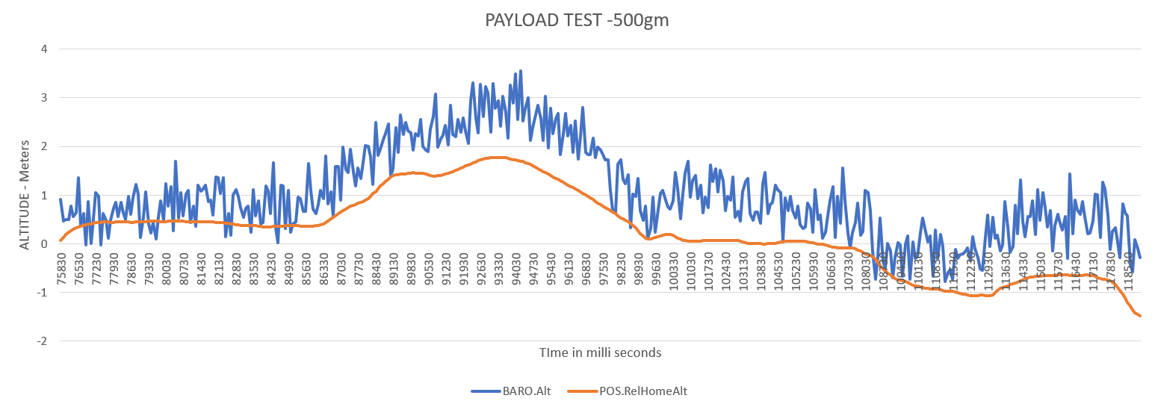

**Figure 7.** Payload test 500grams

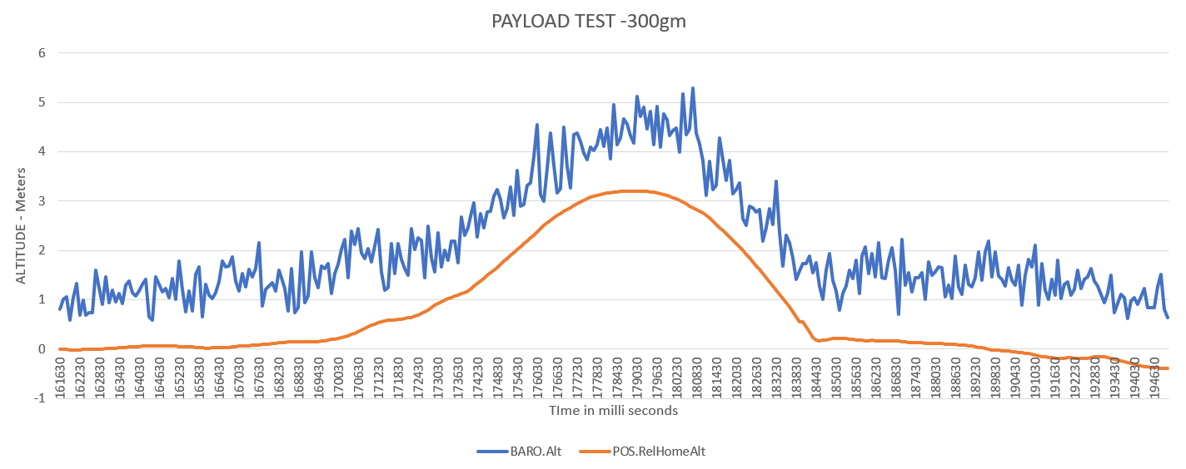

**Figure 8.** Payload test 300grams

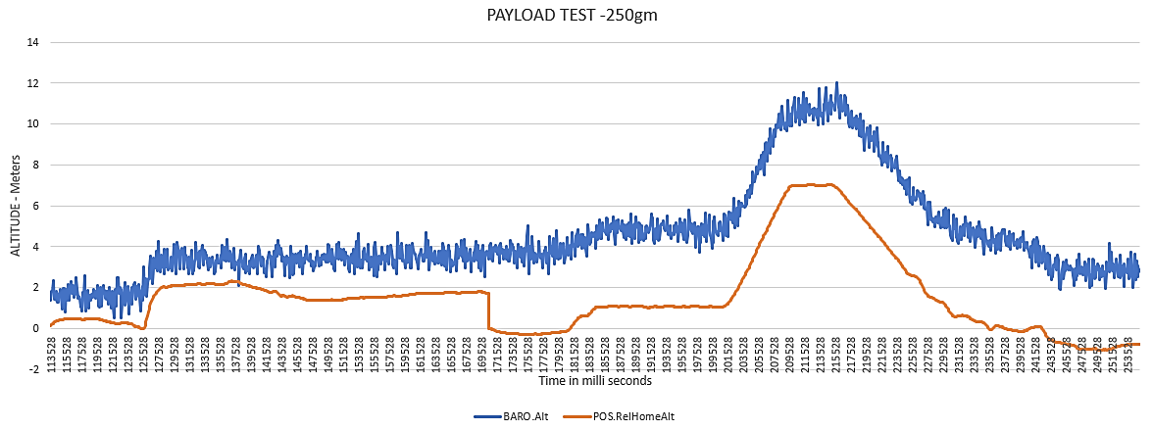

**Figure 9.** Payload test 250grams

* 1. *Autopilot Path testing*

The primary aim of the autopilot path test is to evaluate the drone's performance across various flight modes, assessing the accuracy of waypoint navigation and its ability to adhere to predetermined paths. This test is conducted at a designated college location, where the quadcopter is tasked with following predefined coordinates, or waypoints, set within the outline of a football ground. The test procedure commences by establishing a connection between the mission planner software and the drone via telemetry communication. Once the GPS signal is acquired and stabilized, the waypoints are meticulously selected, with the initial home-point designated at the takeoff location. This systematic approach ensures a thorough analysis of the drone's navigational capabilities and its proficiency in executing autonomous flight missions. The outcomes of this test provide valuable insights into the drone's performance under real-world conditions, guiding further enhancements in autonomous aerial systems.

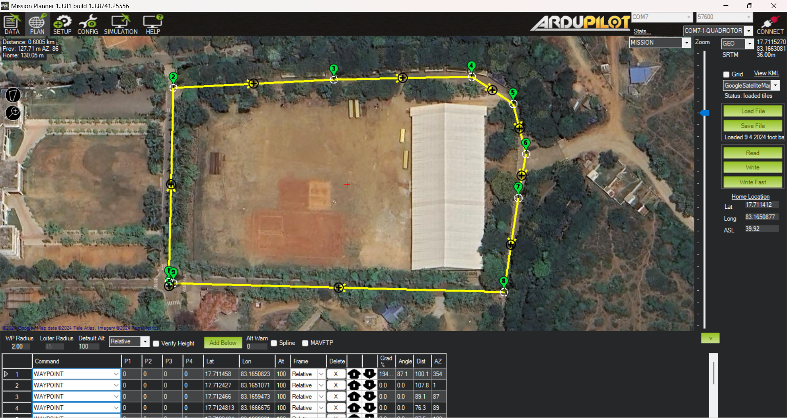

**Figure 10.** Waypoint path visualization for the autopilot test

The figure 10 includes the load file and save file which are the features for saving and loading the predefined wave point path each wave point can be modified again when required the first waypoint is selected as take-off and the last one as land or RTL. The yellow lines with location symbol on it is the path selected.

The yellow box includes the read, write and write fast options, the write option is selected for uploading the wave points into the flight controller using MAV link through communication device telemetry.

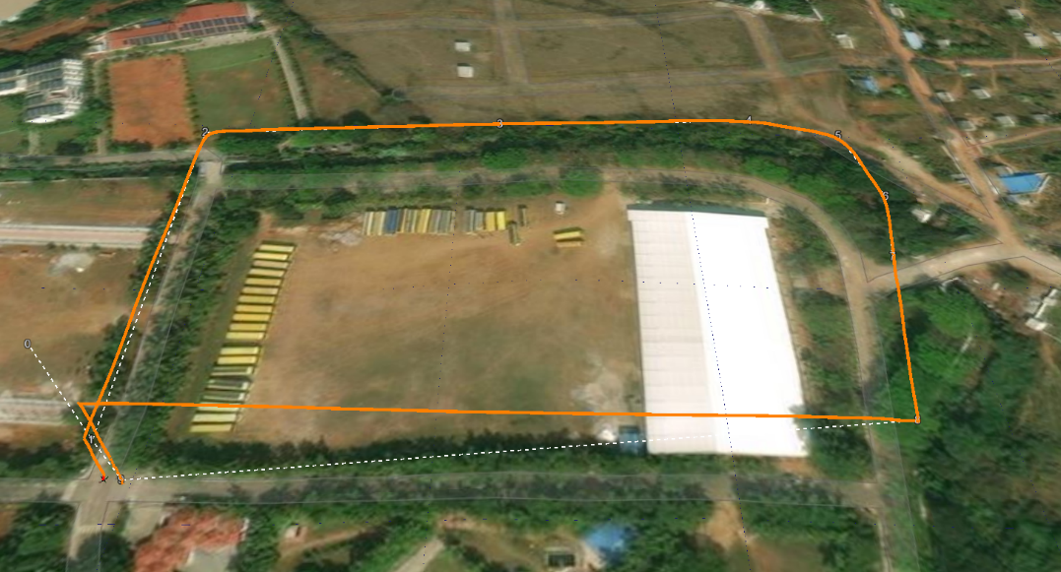

**Figure 11.** UAV flight path in autopilot mode

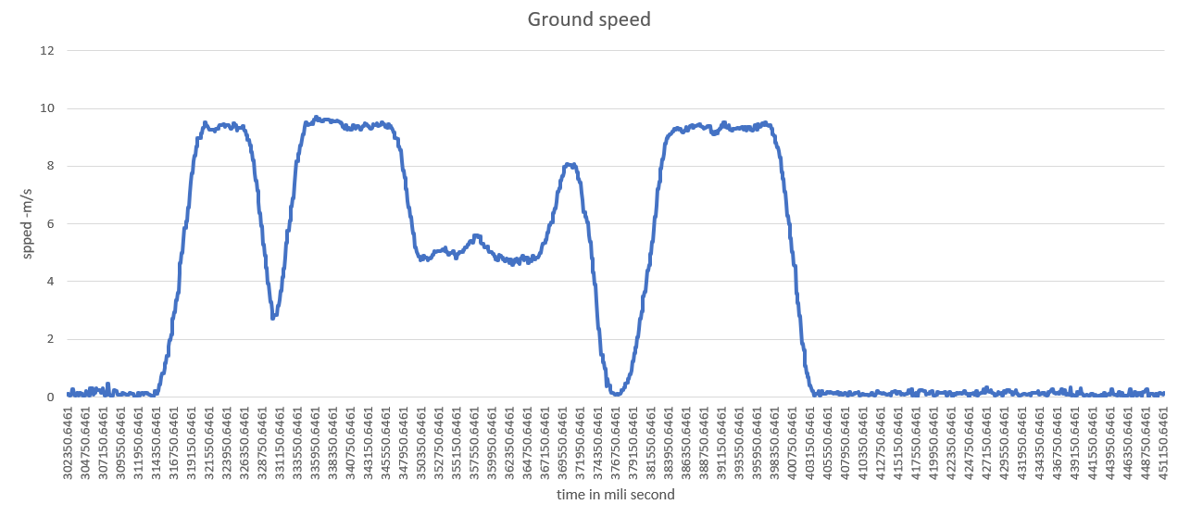**Figure 12.** Speed graph of the autopilot test

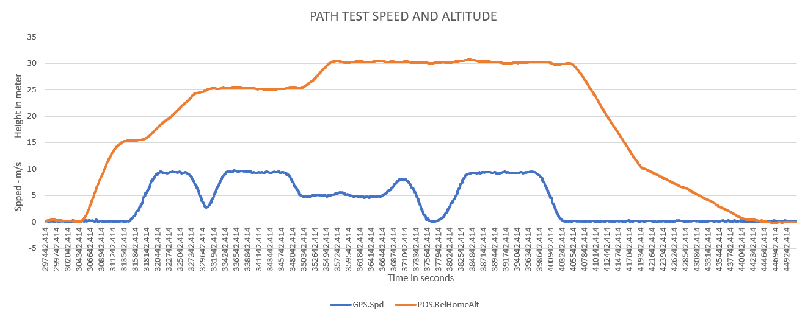

**Figure 13.**Speed and Altitude graph of the autopilot test

Figure 11 represents the 3d Drone flight path in which drone has followed according to the wave points uploaded. In the path test the maximum ground speed achieved by the UAV is 9.716 meter per second and the maximum height reached is 30 .67 meters these results are observed from the graph in the figure 13. Whereas the average speed of the drone is 4m/s the total time taken for the Quadcopter to Fly all the path is 2.15 minutes. At the moment of test the observed wind speed is 23 km/h and the temperature is around 38 degrees centigrade. The predefined least and highest attitudes are 15 meters and 30 meters, these are set with a precautionary intension of safety not to damage the UAV.

1. **Results**

The quadcopter demonstrated effective flight characteristics in standard operational conditions, maintaining a consistent hover and promptly responding to ground control commands. However, flight tests revealed performance variations influenced by environmental factors such as wind direction and speed. While generally adhering to expected behavior, deviations occurred, particularly in gusty wind conditions, leading to parameter errors.

For instance, altitude deviations at 10m and 20m were measured at 25.8 and 41.1, respectively. Despite these deviations, the quadcopter exhibited stability within the expected ranges along the X, Y, and Z planes, with accelerometer values of 0.323 m/s^2, 0.017 m/s^2, and -9.8 m/s^2, respectively. Standard deviations across the X, Y, and Z axes were calculated at 0.71, 0.98, and 2.12, respectively. Analysis suggests that payloads below 250g are more conducive to achieving altitude and stability with reduced deviation.

Despite these findings, it's important to acknowledge the limitations of the experimental setup and potential sources of error, including pilot proficiency, sensor accuracy, and calibration. These results offer valuable insights into the quadcopter's performance characteristics and highlight areas warranting further investigation. Consequently, these findings hold significance for guiding the development of quadcopter systems, enhancing their overall reliability and maneuverability.

1. **Conclusion**

Finally, the quadcopter testing findings considerably improve our understanding of its behavior in real-world circumstances, providing essential recommendations for future research and development efforts in the field of autonomous aerial systems. The study's principal goals were to test the quadcopter's performance under various flight situations and to evaluate its efficacy. Throughout the testing procedure, data on aspects like as flight length, altitude stability, and system reaction were collected to provide a thorough picture of the quadcopter's capabilities. Although the quadcopter functioning as predicted, there were minor aberrations, notably in windy conditions. These differences, caused by wind gusts, highlight the significance of taking environmental factors into account during flight operations.

Under typical operating conditions, the quadcopter exhibited efficient flying qualities, maintaining a constant hover and responding quickly to ground commands. However, the testing also highlighted how environmental conditions, such as wind direction and speed, affect performance.

# **References**

|  |  |
| --- | --- |
| [1] | "Pixhawk.org," p. https://pixhawk.org/standards/#autopilot. |
| [2] | M. F. A. R. e. al, ""Performance of loiter and auto navigation for quadcopter in mission planning application using open source platform," *IEEE,* no. doi: 10.1109/ICCSCE.2017.8284431., pp. 342-347, 2017. |
| [3] | A. planner, p. https://ardupilot.org/planner/index.html, 2024. |
| [4] | N. S. a. P. P. Sven Lange, "Autonomous Landing for a Multirotor UAV," *Conf. on Simulation, Modeling and Programming for Autonomous Robots.,* no. https://nikosuenderhauf.github.io/assets/papers/lange08landing.pdf, 2008. |
| [5] | A. D. a. R. L. P. Castillo, "Real-time stabilization and tracking of a four-rotor mini rotorcraft," *IEEE Transactions on Control Systems Technology,* pp. pp. 510-516, doi: 10.1109/TCST.2004.825052., 2004. |
| [6] | M. A. I. B. a. M. S. M. T. C. Mallick, "Design & implementation of an UAV (Drone) with flight data record," *International Conference on Innovations in Science, Engineering and Technology (ICISET),* no. Dhaka, Bangladesh, 2016, pp. 1-6, doi: 10.1109/ICISET.2016.7856519., 2016. |
| [7] | P. R. S. A. W. M. B. S. A. G. K. Chang, "LiPo battery energy studies for improved flight performance of unmanned aerial systems," *Proc. SPIE 9837, Unmanned Systems Technology XVIII, ,* p. https://doi.org/10.1117/12.2223352, 2016. |
| [8] | J. Estevez, G. Garate, J. Lopez-Guede and M. Larrea, " Review of Aerial Transportation of Suspended-Cable Payloads with Quadrotors," *MDPI,* no. https://doi.org/10.3390/drones8020035, 2024. |

© 2024 the Author(s), licensee AIMS Press. This is an open access article distributed under the terms of the Creative Commons Attribution License (https://creativecommons.org/licenses/by/4.0)